North York, 4th of March 2020

To whom it may concern:

I would like to submit the manuscript “Characterizing the Strong Gravity Prior” by Björn Jörges and Joan López-Moliner to be considered for publication at PLOS ONE. This manuscript has been published as a PrePrint on PsyArXiv, but is not being reviewed or about to be submitted elsewhere.

In this paper, we extend a simple model of time-to-impact estimation for parabolic motion to account for a wider range of results. We then use this model to determine the standard deviation of an internal representation of gravity, which we propose to interpret as a Strong Prior in a Bayesian framework of perception.

Please note that we have published a manuscript based on this dataset (Jörges & López-Moliner, 2019). While we repeat some of the information from our previous paper for the convenience of the reader, the present manuscript focusses on the novel insights gained from simulating the motion extrapolation process. We will gladly make any adjustments you deem necessary to minimize the overlap.

Best regards,

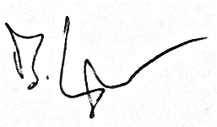

Björn Jörges

**Reference:**

Jörges, B., & López-Moliner, J. (2019). Earth-Gravity Congruent Motion Facilitates Ocular Control for Pursuit of Parabolic Trajectories. Scientific Reports, 9(1). https://doi.org/10.1038/s41598-019-50512-6